PERSONAL INFORMATION | Teodor Penev
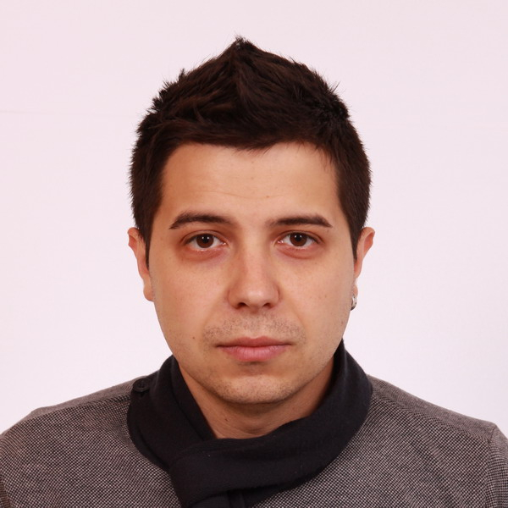 |   12, Rila, Svishtov, 5250, Bulgaria
 |  0895761848

t.g.penev@gmail.com
 | Sex Male | Date of birth 15/01/1987 | Nationality Bulgarian

WORK EXPERIENCE

(15/05/2013 – 15/09/2014) | Crew Member
(15/05/2013 – 15/09/2014) | McDonnald’s (Kill Devil Hills, North Carolina, United States)
(15/05/2013 – 15/09/2014) | - provide customers with a quick and accurate service  - food preparation and cooking the wide variety of food using a broad range of equipment and tools.  - cleanliness and hygiene
(15/05/2013 – 15/09/2014) | Business or sector Quick service restаurant
(01/04/2010 – 10/09/2011) | Operator Maintenance
 | Svilosa (Svishtov, Bulgaria)
- control of machine for pulp using computer command center
- maintenance of machine
 | Business or sector Production of sheet celuloza
(22/08/2008 – 09/01/2009) | Junior Specialist
 | Ministry of Interior(Montana, Bulgaria)
 | - Work like computer operator reception and processing emergency calls on single national number 112/911.
 | Business or sector Emergency assistance
(10/03/2007 – 10/08/2007) | Computer Operator
 | Insomnia (Svishtov, Bulgaria)
- customer service
- cash register operation
- maintenance of computers
- responsibility for cash
 | Business or sector Computer internet services

EDUCATION AND TRAINING

(02.09.2014 - Present) | Software Engineering (0 level completed)
(02.09.2014 - Present) | Software University, Sofiq
(02.09.2014 - Present) | C# Basics, Java Basics, Web Fundamentals (HTML & CSS), Team, Teamwork and Personal Skills…
(15.09.2011 - Present) | Business Informatics (3rd year completed)
(15.09.2011 - Present) | Academy of Econimics “D.A.Cenov”, Svishtov
(15.09.2011 - Present) | Studied fundamental knowledge for C# , SQL Server, Microsoft Office(Word, Exel, PowerPoint, Access)  ,Operation System(Windows,Linux,Unix), Mathematics, Statistics, Аccounting, Planning and Programming, Computer networks, Finance…
(15.09.2003 – 24.05.2006) | Information technology with intensive study of English.
 | High school “Dimitar Blagoev”, Svishtov
 | Studied English, Мathematics, Informatics, Geography, History…
PERSONAL SKILLS

Mother tongue(s) | Bulgarian
Other language(s) | UNDERSTANDING |  | SPEAKING |  | WRITING
Other language(s) | Listening | Reading | Spoken interaction | Spoken production
English | C1 | C1 | B2 | B1 | B1
German | B1 | B1 | A2 | A2 | A2

Communication skills | - exelent communication skills gained through my experience as Junior Specialist in 112/911  Emergency Center and my previous experience working with clients.

Job-related skills | - willingness and ability to absorb new knowledge

Computer skills | - basic knowledge in programming, proficiency MS Office integrated applications

Driving licence | - B

ADDITIONAL INFORMATION

Publication  Projects  Honours and awards | - Made part of the publication : Application of the management of business processes (BPM) in Bulgarian practice.  - Involved in teamwork assignment (Java, HTML and CSS) Small projects on VB and C # and a large one developed project “ System Purchase Automobile ” on C # and SQL Server.  - Special scholarship for publication : Application of the management of business processes (BPM) in Bulgarian practice.

GitHub developer profile  Personal blog | - https://github.com/TeodorPenev  - http://penevsource.wordpress.com/

